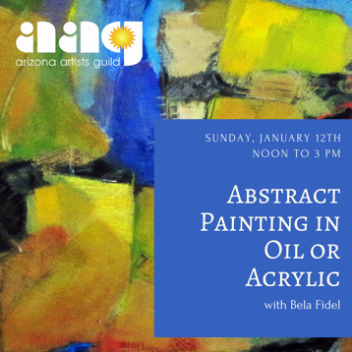**Abstract Painting in Oil or Acrylic with Bela FidelSupply List:**

**Acrylic paints:**

Spritzer   
Palette  
Brushes   
One or two 12x12 canvas or canvas board  
Palette knife  
Paper towels

**Oil paints:**

Gamsol or other odorless solvent and a container  
A painting medium of your choice (Liquin, linseed, etc.)   
Palette  
Brushes   
Palette knife  
Paper Towels