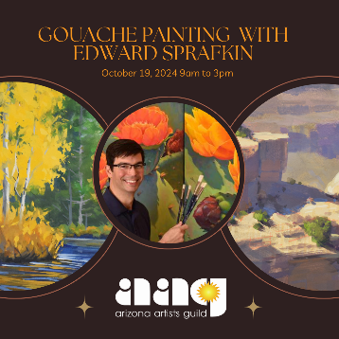
Gouache Painting Workshop with Edward Sprafkin Supply List:
Recommended Paints:
I prefer Winsor & Newton Designer Gouache but there are many brands available. Just make sure that you always buy Professional Artist-Quality Paints. Note: Acryla-gouache is not recommended for this workshop.

Colors: Suggested Palette of 12 colors. You are free to use your favorite colors too!
Permanent White (Big Tube - 37 ml 1.25 fl oz)
Primary Yellow , or Spectrum Yellow
Perm. Yellow Deep
Yellow Ocher
Flame Red, Primary Red, or Winsor Red
Permanent Alizarin Crimson
Burnt Sienna
Ultramarine Blue
Winsor Blue
Winsor Violet
Brilliant Green
Perm. Sap Green - or - Olive Green

Palette: Butcher Tray 7.5 x 11 inches

Surfaces: There are plenty of surface options for gouache painting.
Fluid 100 Cold Press Watercolor Block 300 lb. sizes 5x7 up to 9x12.
Cottonwood Arts Cold Press Block 5x7 up to 8x10
Or, any cold press watercolor paper or pad will be suitable.

Brushes: I like Princeton and Robert Simmons brushes but any brand synthetic brush will work.
Princeton Velvet Touch Short Handle Wash 1”, ¾”, ½” - Or -
Princeton Select Series 3750 Synthetic Flat Wash 1”, ¾”, ½”
Princeton Long Round Size #10
Simply Simmons #0 Liner.
Pencils: Prismacolor Color Pencil PC922 Poppy Red or similar color, or a simple graphite HB pencil.
Water Mister: Chroma Atelier Water Sprayer.
Brush washer: Any oversized empty yogurt/cottage cheese container.
Paper Towels or Rags

